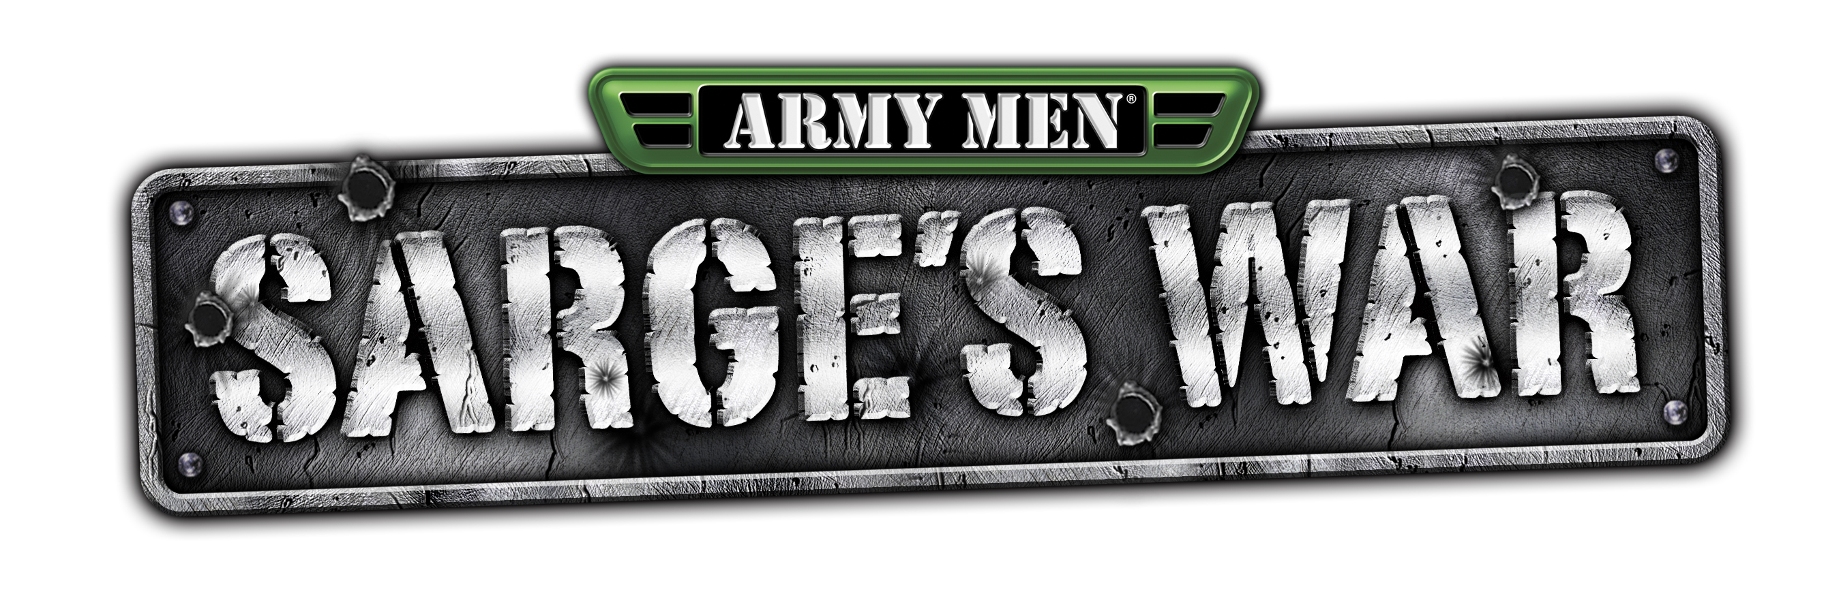

The 3DO Company

Title Data Sheet

Publisher: The 3DO Company

Developer: The 3DO Company
Platform: Nintendo® GameCube
Expected Ship Date: March 2003

Number of Players: One player and Multiplayer Modes

Category: Action Adventure
Rating: RP (“Teen” expected)

Story
The player will play as Sarge, now an army of one, against the whole of the Tan Army, under the leadership of Colonel Malice. All of the Heroes have been wiped out in a brutal Tan ambush and the Tan have found a new weapon of mass destruction that can reduce a platoon of soldiers into a mass of melted plastic.

Sarge must go renegade and avenge the death of his fallen heroes, to take his revenge on the Tan Army and destroy Colonel Malice.

Game Play
Sarge’s War is a 3rd person character based 3D combat action game set in the retro world of plastic toys. Sgt. Rock meets Toy Story. It features a mixture of intense 3rd person shooting action and tactics set in war torn-“Their World” (40%) and “Our World” (60%). Access to both these worlds is obtained through portals.

The player controls Sarge in a movie-like combat experience featuring incredible plastic destruction effects. Gameplay is similar to Sarge’s Heroes with less emphasis on run and gun and strafing, and more emphasis on actual combat tactics that require the player to use cover, stealth, and specific weapons to defeat specific enemies. Sarge’s War will be harder edged than previous games in the Sarge’s Heroes series.

Key Features
- “Real time Destruction”- characters will take visible damage such as dynamic holes and missing limbs and will retain damage throughout gameplay
- Screen relative control and camera system that features movie like camera usage
- Players can collect plastic from fallen enemies and use at the “Recyclotron” to build new weapons
- Over 600 fluid motion-capture animations, including incredible deaths and Hollywood style combat moves
- Enemy A.I. will seek cover, hunt, patrol, outflank, attack, and avoid the player – creating realistic and unpredictable tactical challenges for the player in every mission!
- Incredible photo-real graphics and art with dynamic lighting and shadowing

Editorial Contact: Rannie Yoo

Linn PR
(415) 552-1183
rannie@linnpr.com

